# TOURISM MANAGEMENT SYSTEM

## Mini Project Report

Submitted to

## Visvesvaraya Technological University Belagavi-590018

by

**Vandana Mohan Gouda USN:4SU17CS115**

**Sowbhagya K USN:4SU18CS402**

Under the guidance of **Mr. Amith K S** Assistant Professor

In partial fulfillment of the requirements for the award of

**VII Semester WEB TECHNOLOGY LABORATORY WITH MINI PROJECT**



**Department of Computer Science and Engineering SDM INSTITUTE OF TECHNOLOGY UJIRE- 574 240**

**2020**

**S. D. M. INSTITUTE OF TECHNOLOGY**

(Affiliated To Visvesvaraya Technological University, Belagavi )

**UJIRE-574240**

**Department of Computer Science and Engineering**

**CERTIFICATE**

Certified that the project work entitled “**TOURISM MANAGEMENT SYSTEM**” is carried out by VANDANA MOHAN GOUDA bearing USN **4SU17CS115** and SOWBHAGYA K bearing USN **4SU18CS402** in partial fulfillment for requirements for **VII Semester WEB TECHNOLOGY LABORATORY WITH MINI PROJECT** of the Visvesvaraya Technological University, Belagavi during the year 2020-21. It is certified that all corrections / suggestions indicated for Internal Assessment have been incorporated in the report deposited in the departmental library. The project report has been approved as it satisfies the academic requirements in respect of project work prescribed for the said Laboratory.

### Signature of the Guide Signature of the H.O.D

**(Mr.Amith KS) (Dr. Thayagaraju G.S)**

EXTERNAL VIVA

Name of the Examiners:

1.

2.

# ACKNOWLEDGEMENT

## We express our deepest gratitude to our guide Mr. Amith K S, Asst. Professor Department of Computer Science and Engineering, for his valuable guidance and encouragement while doing this project work.

We are obligated to **Dr Thyagaraju G S**, Head of the Department and **Dr.Ashok Kumar T,** Principal for their advice and suggestions at various stages of the work. We also extend our heartfelt gratitude to Mr. Arjun K, Asst. Professor Department of Computer Science and Engineering, for his assistance.

We also extend our thanks to the management of SDM Institute of Technology, Ujire, for providing an excellent study environment, reference materials and laboratories facilities. We remain grateful to the co-operation and help rendered by the teaching and non-teaching staff to the department.

**Vandana M G Sowbhagya K**

# ABSTRACT

The Tourism Management System is an application which help in maintaining the operations performed related to sight-seeing and travelling. Most of the people in this world like to travel from one place to another no matter whether it is a small or large distance. Some people like to travel by train, flight, bus or by any other means of transport. The tourism management system application is designed for the travelers in which there is an option of doing the package booking in order to reach the intended destination. The tourism management system is one of the application that will help the customers to book the package that have different categories of facilities, through this application. The tourism management system allows the user to view all the details such as hotel, food and transport facility etc. The system also provides different package categories like family, couple, friends etc. Finally user need to just login into the application and can find the details and book the package of his own interest and complete the bookingprocess.

# Table of Contents

**Page No.**

**Acknowledgement i**

Abstract ii

Table of Contents iii

List of Figures iv

Chapter1 Introduction 1

Chapter2 Literature Review 2

2.1 Introduction to web

Chapter3 Problem Formulation 3-4

3.1 Problem statement

3.2 Aim of the work

3.3 Objectives

Chapter4 Requirement Specification 5-7

4.1 Functional Requirements

4.2 Non-Functional Requirements

4.3 Software Requirements

Chapter5 Design 8-9

5.1 High Level Design

5.2 Low Level Design

Chapter6 Implementation 10-12

Chapter7 Results and Discussion 13-15

Chapter8 Conclusions and Scope for future work 16

Bibliography 17

Personal Profile 18

# List of Figures

|  |  |  |
| --- | --- | --- |
| **Figure** | **Description** | **Page No.** |
| **5.1** | **Low Level Design** | **8** |
| **5.2** | **High Level Design** | **8** |
| **7.1** | **Home page** | **13** |
| **7.2** | **About Page** | **13** |
| **7.3** | **Package List** | **14** |
| **7.4** | **Package Detail and Booking Page** | **14** |
| **7.5** | **Admin Dashboard** | **15** |
| **7.6** | **Admin-Package Update Page** | **15** |

## Chapter1

**Introduction**

The Tourism Management System has been advanced by opting the Online Booking and information system. The Travel search and Booking Software is an automated system that has been developed for the tour travelers and tour operators. The website allows one to log on and perform the real time and online booking. The website has lot of information too for the convenience of the tourist which shows the various cities and places along with the complete details and images of the tourist places. The details also include the distance of the tourist place from major cities and the how to reach and reservations.The transportation and accommodation is also available in this online service. The administration has to manage the travels details, users and itsupdation.

The Tourism Management System is a web based application. The main purpose of “Tourism management system” is to provide a convenient way for a customer to book tour package. The objective of this project is to develop a system that automates the processes and activities of a tour is magency.The Existing System is not able t o update the detail sand provide it online immediately. The online services are not in use so there is no remote access. In the present system a customer has to approach various agencies to find details of places and to book tickets.This of ten requires a lot of time and effort.We provide approach skills to critically examine how a tourist visits and its ability to operate in an appropriate way when dealing with the consequences of tourism, locally, regionally, and nationally including visitor security and ecological influences. It is tedious for a customer to plan a particular journey and have it executed properly. The project ‘Tourism Management System’ is developed to replace the currently existing system, which helps in keeping records of the customer details of destination as well as userinformation.

## Chapter 2

**Literature Review**

A lot of tourism researchers have put ample emphasis on the use of the Internet in travel and tourism industry. Not only the buyers but suppliers too can get benefitted by the use of Internet. They can promote their offers on their portals and in turn, can sell the products at any time to any customer globally. They can also control the servers to display information on their services/products at an electronic speed. A supplier see the benefits of using the Internet for selling his services in many ways as he experiences a significant drop in distribution costs, an increase in revenues, and an increased market share. In the same way, use of the Internet allows travelers to interact freely with the tourism suppliers for the necessary information, and to make themselves ultra-comfortable in order to purchase products/services at any time and any place. But there are a lot of researchers, who think that extensive use of internet may very well, one day, be able to end the role of travel agents or for that matter, the travel agencies. Internet is being used as a disinter- mediating agent as it doesn’t allow the participation of a middlemen in the traveler-agent-destination/supplier network in the travel industry. But what these researchers ignore that travel agencies provide personal information and advice to the travelers and as far as their capability of giving advice and information doesn’t get diminished, they are not going to extinct in the aforementioned network

**2.1 Introduction to web**

The Web is the common name for the World Wide Web, a subset of the Internet consisting of the pages that can be accessed by a Web browser. Many people assume that the Web is the same as the Internet, and use these terms interchangeably. However, the term Internet actually refers to the global network of servers that makes the information sharing that happens over the Web possible. So, although the Web does make up a large portion of the Internet, but they are not one and same.Web pages are formatted in a language called Hypertext Markup Language (HTML). It this language that allows users to click through pages on the Web via links. The Web uses HTTP protocol to transmit data and share information. Browsers such as Internet Explorer, Google Chrome or Mozilla Firefox are used to access Web documents, or Web pages, which are connected via links.The Web is just one of the ways that information is shared over the Internet.

# Problem Formulation

## Chapter 3

**3.1 Problem Statement**

The Existing System is not able to update the details and provide it online immediately. The online services are not in use so there is no remote access. The mismanagement ofthe confidential data like addresses and other is high leads to threat. The user has to search for the details manually asking to the provider. It is less user oriented. The system consumes more manpower. The owner of the tourism provider is not able to directly contact withthe customer and their interests. Only single system which is only to enter the details in computer for future use. The reports cannot be generated automatically. Recoding is difficult as it need more paper work. The services are not reliable on phone. The other booking are not possible.

## 3.2 Aim of the work

The propose system is highly automated and makes the travelling activities much easier and flexible. The user can get the very right information at the very right time. The project management is easy, simple and retrievable. This will increase the trust of the customer into the travel company as well. The system is highly secured and authenticated. The user can themselves check and book the reservations. They can cancel the reserved package only before it is confirmed by the admin. If there is any issue regarding package user can request the suggestion from the admin.

## 3.3 Objectives

* Implementation of user registration and login pages.
* Implementation of modules for Display of packages from various places.
* Implementation of admin modules for managing and Display packages and pages of the website
* Implementation of user modules to help the users to fetch details and book the package in the form of different categories.
* This application is developed to provide best travelling services to the customers.We have developed tourism management system to provide a search platform where a tourist can find their tour places according to their choices. This system also helps to promote responsible and interesting tourism so that people can enjoy their holidays at their favorable places.This system also helps to develop tourism with different cultures so that they enrich the tourism experience and buildpride.We develop this system to create and promote forms of tourism that provide healthy interaction opportunities for tourists and locals and increase better understanding of different cultures, customs, lifestyles, traditional knowledge and believes. This system also provide a better way to connect with variousplaces.

# Requirement Specification

## Chapter 4

## 4.1 Functional Requirements

**User Login:**

* User can register yourself and login with valid email and password.
* Forgot Password(user Can recover own password) and change Password
* Tour Booking and Manage Booking
* Generate Issue(Regarding Complaint)

**Admin Login:**

* Admin can create Package and Manage package
* Manage Users and Manage Booking
* Manage Enquiries and Manage issues
* Change Password and Manage Pages
* Admin Dashboard

## 4.2Non Functional Requirements

## Performance :

* Performance of the system should be fast and accurate
* System shall handle expected and unexpected errors
* System should be able to handle large amount of data

**Safety :**

* Must be two servers.one main server and one backup server

**Security :**

* User authentication and validation of members using their unique member ID
* Only the admin will see and manage all users account.
* Proper user authentication should be provided.

**Interface:**

* The interface should provide a recognizable functionality.
* Interface text should be understandable ,and convey appropriate meaning.

**4.3SoftwareRequirements**

|  |  |  |
| --- | --- | --- |
| **Sl.No** | **Software** | **Specification** |
| **1.** | **Web Browser** | **Google Chrome** |
| **2.** | **Operating System** | **Windows 10** |
| **3.** | **Technology used** | **HTML5, CSS5,PHP,JavaScript,Bootstrap** |
| **4.** | **Database** | **MySQL** |
| **5.** | **Tool used** | **Wamp Server** |

A web browser, or simply "browser," is an application used to access and view websites. Common web browsers include Microsoft Internet Explorer, Google Chrome, Mozilla Firefox, and Apple Safari. The primary function of a web browser is to render HTML, the code used to design or "markup" webpages. Each time a browser loads a web page, it processes the HTML, which may include text, links, and references to images and other items, such as cascading Style sheets and JavaScript functions. The browser processes these items, then renders them in the browser window.

An operating system is a software which acts as an interface between the end user and computer hardware. Every computer must have at least one OS to run other programs. An application like Chrome, MS Word, Games, etc needs some environment in which it will run and perform its task. The OS helps user to communicate with the computer without knowing how to speak the computer's language. It is not possible for the user to use any computer or mobile device without having an operating system.

A script or scripting language is a computer language with a series of [commands](https://www.computerhope.com/jargon/c/command.htm) within a file that is capable of being executed without being [compiled](https://www.computerhope.com/jargon/c/compile.htm). Good examples of [server-side scripting](https://www.computerhope.com/jargon/s/server-side-scripting.htm) languages include [Perl,](https://www.computerhope.com/jargon/p/perl.htm) [PHP](https://www.computerhope.com/jargon/p/php.htm), and [Python](https://www.computerhope.com/jargon/p/python.htm). In this project PHP is used for webapplication development.The best example of a client side scripting language is [JavaScript](https://www.computerhope.com/jargon/j/javascript.htm). A full list of scripting languages and other programming languages can be found through our [programming language](https://www.computerhope.com/jargon/p/programming-language.htm) definition. Inthis project css, html, javascript are used for client side programing.

MySQL is the world’s most popular open source database. With its proven performance, reliability,and ,MySQL has become the leading database choice for web-based applications, used by high profile web properties including Facebook, Twitter, YouTube, and all five of the top five websites. In this MySQL is used for data storage.

WAMP is a [free and open-source](https://en.wikipedia.org/wiki/Free_and_open-source) [cross-platform](https://en.wikipedia.org/wiki/Cross-platform) [web server](https://en.wikipedia.org/wiki/Web_server)[solution stack](https://en.wikipedia.org/wiki/Solution_stack) package developed by Apache Friends, consisting mainly of the [Apache HTTP Server,](https://en.wikipedia.org/wiki/Apache_HTTP_Server) [Maria DB](https://en.wikipedia.org/wiki/MariaDB) [database,](https://en.wikipedia.org/wiki/Database) and [interpreters](https://en.wikipedia.org/wiki/Interpreter_(computing)) for scripts written in the [PHP](https://en.wikipedia.org/wiki/PHP) and [Perl](https://en.wikipedia.org/wiki/Perl) [programming languages.](https://en.wikipedia.org/wiki/Programming_language)

# Design

**System Design:**

## Chapter 5

Systemdesignisaoneimportantphaseinsoftwareorsystemdevelopment.Systemdesign can be defined as method of defining different modules required for software or system to fulfill allrequirements.

If Regis

No

Yes

Register

USER

ADMIN

LOGIN



Manage Package Booking

Manage pages

Manage enquiry

Manage issue

Create and manage package

ADMIN HOME

LOGIN

USER HOME



Update profile

View, Book and Cancel packages

View Issue

**Figure 5.1 Figure 5.2**

**High-Level Design Low-Level-Design**

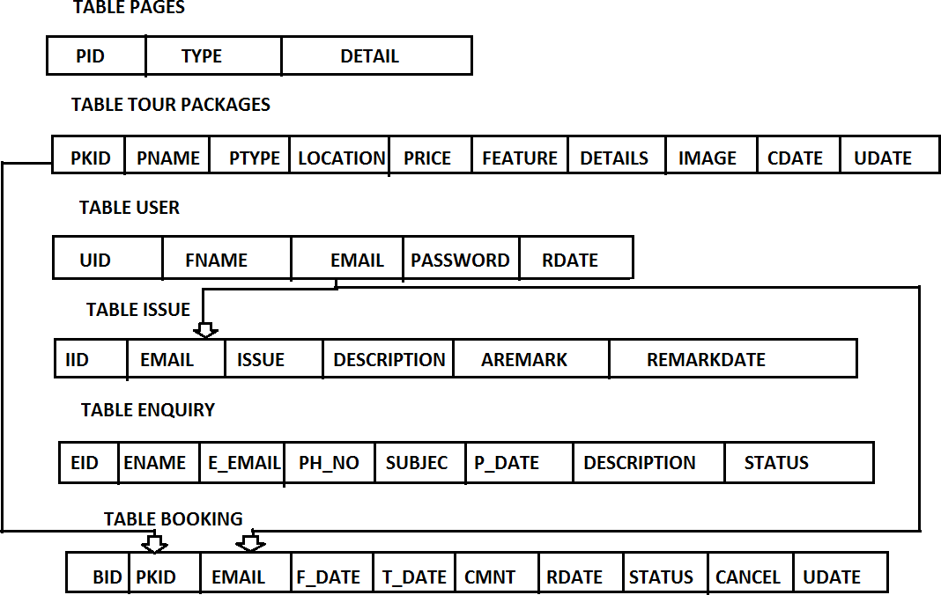**Schema Diagram :**

In this project there are six tables excluding admin table suchas

* + - TablePage that give information about different pages like About, Privacy and Terms
    - TourPackage tells different package details and itsprice
    - TableUser stores the information of theuser
    - TableIssue stores the description of issues created by register user
    - TableEnquiry stores the details of enquiry of anyusers
    - TableBooking stores details about package booked by theusers

# Implementation

## Chapter 6

Implementation is a process of development of an application. Once the system design is completed then actual development of system will starts. The development of application using system design is called the implementation phase. In this phase, largest system is divided into small modules.For each module,algorithms are developed and each algorithm is coded using programming languages. Implementation of proposed system includes the following

## 6.1 Implementation of User Registration+ModuleRegistrationPage:

Step 1: Start

Step 2: Read Username, Email, Phone Number and Password Step 3: Establish connection to TMS database

Step 4: Set session

Step 5: Prepare query to insert user data into tbl_user table of TMS database Step 6: Execution of query

Step 7: End

## Login Page:

Step 1: Start

Step 2: Enter Email and Password

Step 3: Establish connection to TMS database Step 4: Set session

Step 5: Prepare query to select data from tbl_user table of TMS database Step 6: Execution of query

Step 7: Redirect to user home page Step 8: End

## 6.2 Implementation of AdminModule

### Create Package:

Step 1: Start

Step 2: Read Plocation, PName, PType, PPrice, PFeatures, PDetails, PImage Step 3: Establish connection to TMS database

Step 4: Set session

Step 5: Prepare query to insert package data into tbltour_pkg table of TMS database Step 6: Execution of query

Step 7: End

### Manage User:

Step 1: Start

Step 2: Establish connection to TMS database Step 3: Set session

Step 4: Prepare query to select user data from tbl_user table of TMS database Step 5: Execution of query

Step 6: End

## 6.3 Implementation of User Module

### Package Booking:

Step 1: Start

Step 2: Read PId, UserEmail, FDate, TDate, Comment, status Step 3: Establish connection to TMS database

Step 4: Set session

Step 5: Prepare query to insert userpackage data into tbl_booking table of TMS database Step 6: Execution of query

Step 7: End

### View Tour History:

Step 1: Start

Step 2: Establish connection to TMS database Step 3: Set session

Step 4: Prepare query to select data into tbl_booking table of TMS database Step 5: Execution of query

Step 6: End

**Results and Discussion**

**Chapter 7**

Results basically refer to any particular output that comes as a result of the completion of the activities that have been performed as part of the project or a particular project.

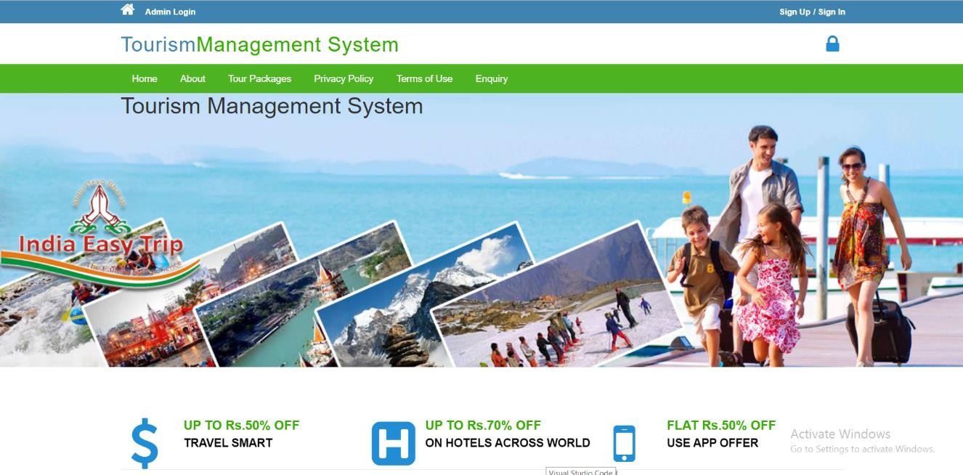

#### Figure 7.1: Home page

This is the home page for both user as well as admin through which admin can login and user can get register, login, and can view general information about the website.

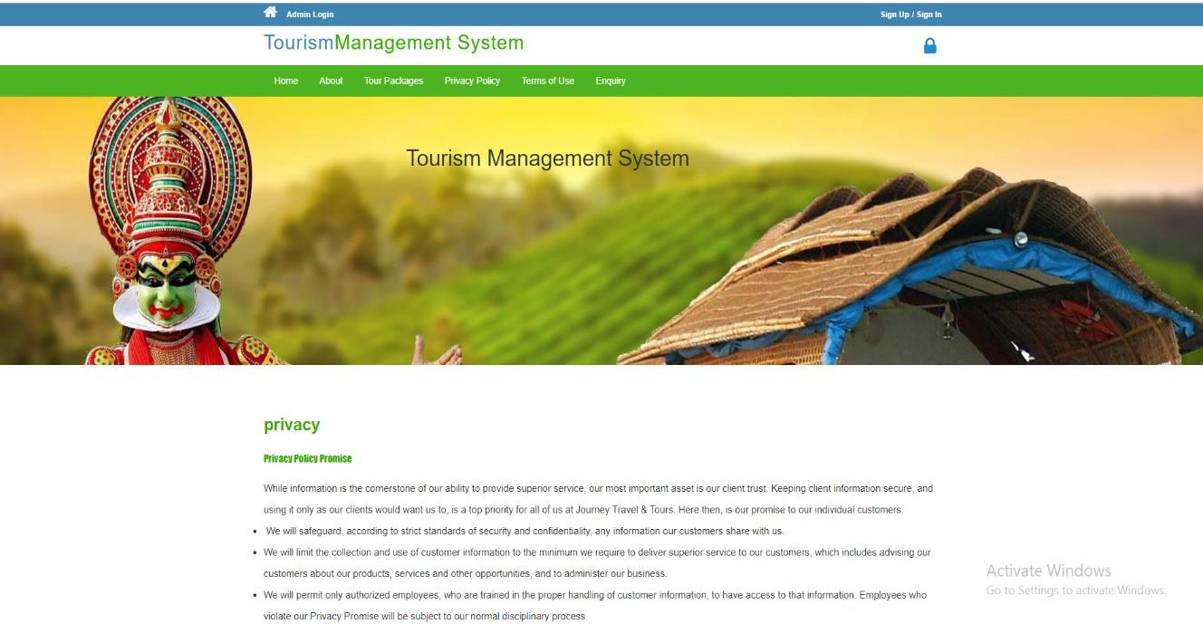

#### Figure 7.2: Privacy Policy

This page provides the complete details about the privacy policies of this website.

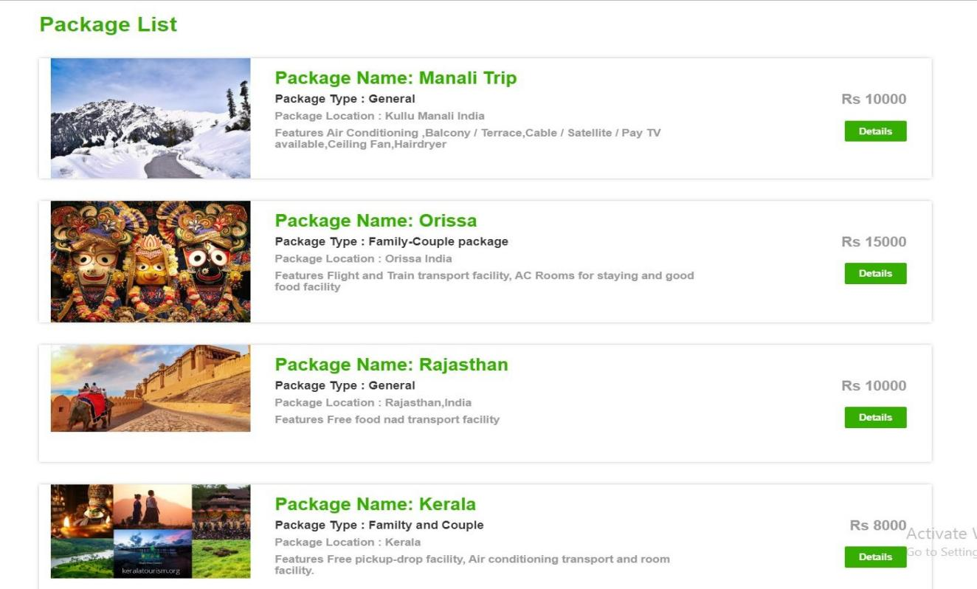

#### Figure 7.3: Package list

This page will provide the details of packages available along with the some of the facilities provided for a particular place.

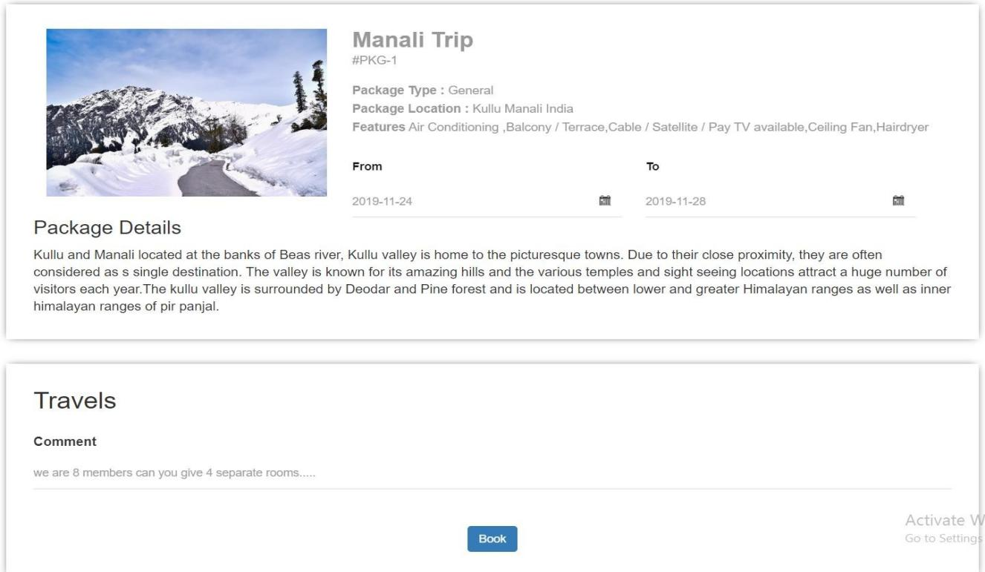

#### Figure 7.4: Package Booking page

This page provides complete details about the selected package, where user can choose the respective dates of tour to book package.

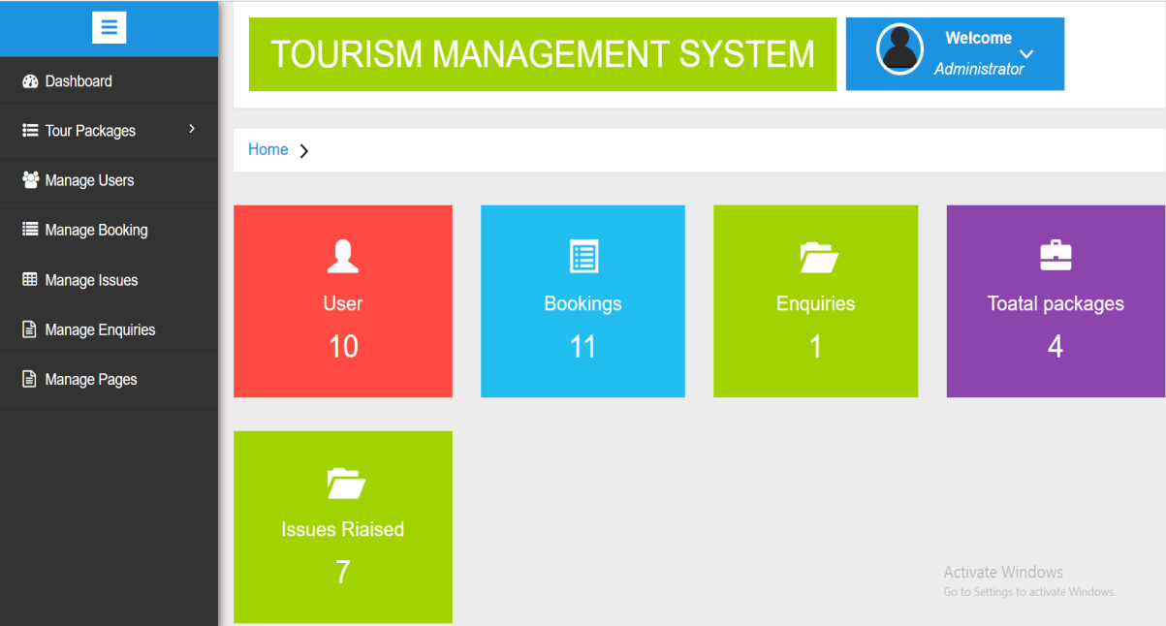

#### Figure 7.5: Admin Dashboard

It is a home page for admin where he can perform all the tasks related to managing website.

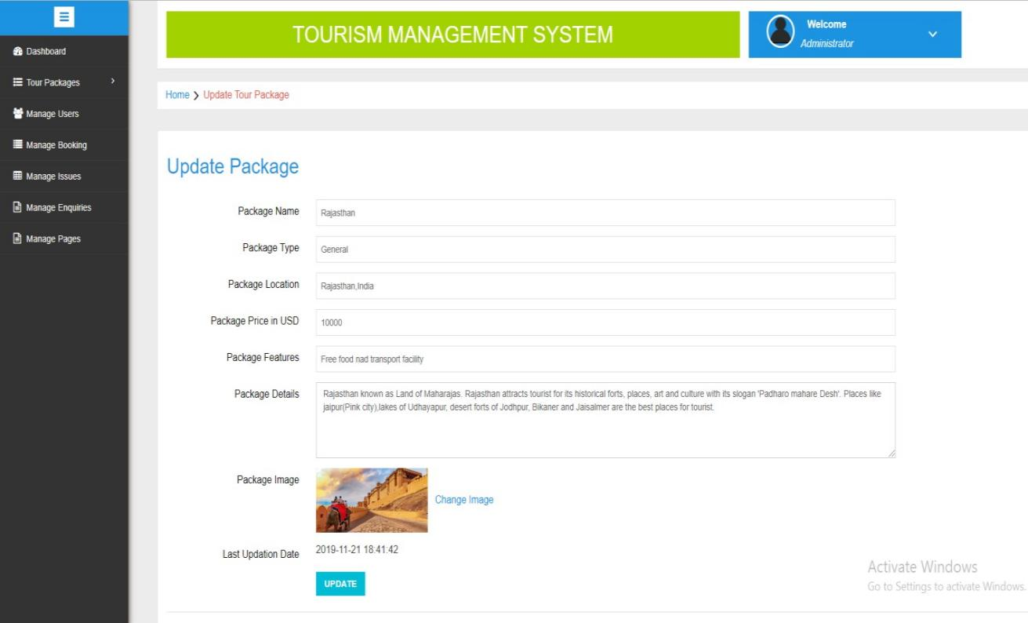

#### Figure 7.6: Admin Page –Package update page

Through this page admin can updates the package details that includes name, type, location and others details.

## Chapter 8

**Conclusions and Scope for future work**

Tourism management system simplifies the management in travelling. It helps in online distribution of tour packages. Fast processing and immediate result with high security is provided. This minimizes the human effort and cost efficient databases. Any navigation through the site is easy. This web application will help tour manager to control and handle the tour related activities effectively and efficiently.Further features can be added to this project like adding hotels, payment method and various transportation agencies.We are interest edin continuing this project by adding more special feature like providing tour packages for out of country.

# Bibliography

1. Randy Connolly, Ricardo Hoar, “Fundamentals of Web Development”,1stEdition, Pearson EducationIndia.
2. Robin Nixon, “Learning PHP, MySQL and JavaScript with JQuery, CSS and HTML5”, 4thEdition, O’Reilly Publications2015.
3. HTML, CSS, JavaScript-[https://www.w3Schools.com](https://www.w3schools.com/)
4. <https://www.researchgate.net/publication/310122350_Tourism_Management_System>
5. [http://myassignmenthelp.info/assignments/marketing-management-assignment- writing-analysis-online-literature-review-tours-travel-industry/](http://myassignmenthelp.info/assignments/marketing-management-assignment-writing-analysis-online-literature-review-tours-travel-industry/)

# Personal Profile

Prof. Amith K S received B.E. degree in Computer Science and

Engineering from AIT Chickmagalore and M.Tech degree in

Network and Internet Engineering from JNNCE Shivamogha.

Pursuing PhD in the area of “Cognitive Radio Network His

subject of interest are web 2.0 and 5G Network.

**Mr. Amith K S,**

**Asst. Prof. Project Guide**

 **Name**: VANDANA MOHAN GOUDA

**USN:** 4SU17CS115

**Address:** D/O Mohan S

Gouda OkkalakeriBinaga

Karwar 581307, Karnataka

**E-mail ID:** [vandanagouda060@gmail.com](mailto:vandanagouda060@gmail.com)

**Contact Phone No:** 8105296307



 **Name:** SOWBHAGYA K

**USN:** 4SU18CS402

**Address:** Sowbhagya

NilayaKillur, Killur post

Belthangadytaluk

D.K-574214

**E-mail ID:** [sowbhagyak1995@gmail.com](mailto:sowbhagyak1995@gmail.com)

**Contact Phone No:** 99016 35782